Drop off and Pick up

Please read through the following document regarding drop off and pick up for your child. We will be utilizing 3 different doors to help traffic students out. I am asking that you try to drop your child off as close to 7:55 as possible. This will help prevent potential behavior issues before school starts.

Siblings: At arrival, drop siblings off near the YOUNGER student’s location. Older siblings will walk outside to their designated location. At dismissal, younger siblings will be dismissed and meet at the older siblings dismissal door.

The locations are:

Main entrance by main doors (upper lot with flag pole): This entrance will be for students in the 5th and 6th grade. Grade levels will line up opposite of each on the designated line.

Main entrance (upper lot with flag pole against brick wall): This entrance will be for students in Mrs. Jarmin’s Kindergarten class (KCJ).

Main entrance (upper lot with flag pole - picnic table area): This entrance will be for students in Mrs. Jensen’s Kindergarten class (KBJ) .

South entrance (back of school by softball/baseball field): This entrance will be for students in the 3rd and 4th grade. Students will line up on their designated line and stand on X’s.

North entrance (lower parking lot by playground and Avery Road): This entrance will be for 1st and 2nd graders. Students will line up on their designated line and stand on X’s.
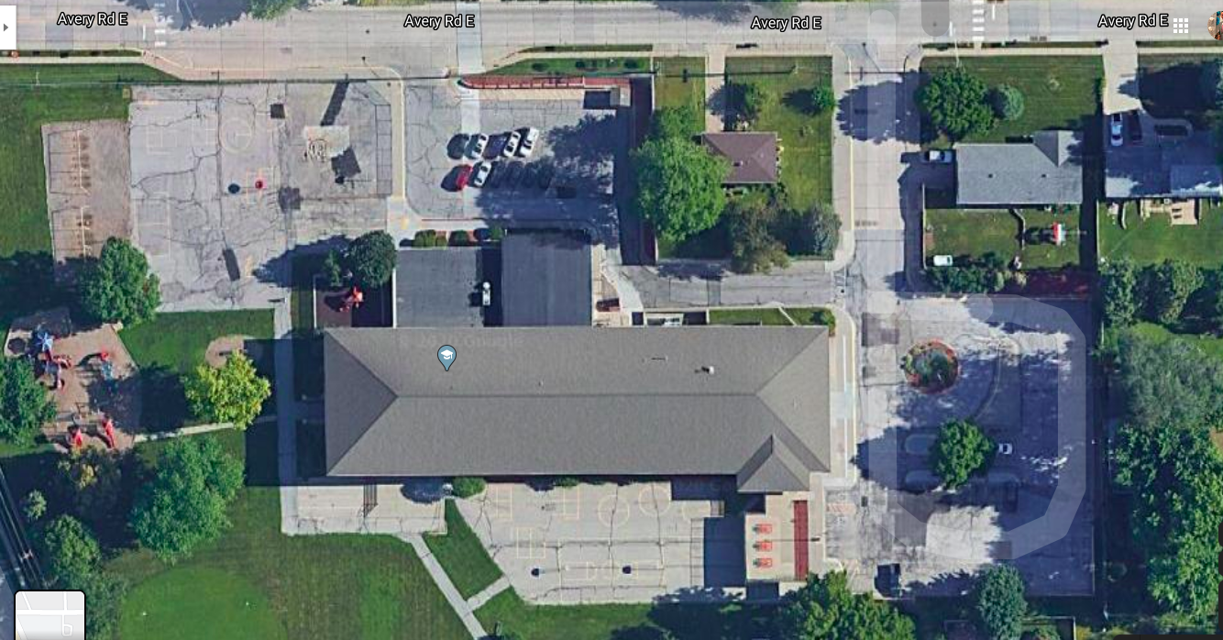
1st and 2nd
3rd and 4th
KBJ
KCJ

5th

6th

